## CHANDIGARH UNIVERSITY

## UNIVERSITY INSTITUTE OF NGINEERING

**DEPARTMENT OF COMPUTER SCIENCE & ENGINEERING**



|  |  |
| --- | --- |
| **Submitted By: Submitted To:**  Abhinav Verma Mr. Vishal Dutt Sir (E14661) | |
| **UID** | 20BCS9258 |
| **Section & Group** | 20BCS_KRG_DM-1 Group A |
| **Subject Name** | Mobile Application Development Lab |
| **Subject Code** | 20CSP-356 |
| **Branch** | CSE |
| **Semester** | 06 |

**INDEX**

|  |  |  |  |  |  |  |  |
| --- | --- | --- | --- | --- | --- | --- | --- |
| **Ex. No** | **List of Experiments** | **Date** | **Conduct (MM: 12)** | **Viva**  **(MM: 10)** | **Record (MM: 8)** | **Total**  **(MM: 30)** | **Remarks**  **/Signature** |
| 1.1 | Installation and  configuration of  Android Studio | 17/02/2023 |  |  |  |  |  |
| 1.2 |  |  |  |  |  |  |  |
| 1.3 |  |  |  |  |  |  |  |
| 2.1 |  |  |  |  |  |  |  |
| 2.2 |  |  |  |  |  |  |  |
| 2.3 |  |  |  |  |  |  |  |
| 3.1 |  |  |  |  |  |  |  |
| 3.2 |  |  |  |  |  |  |  |
| 3.3 |  |  |  |  |  |  |  |
| 3.4 |  |  |  |  |  |  |  |

**Experiment – 1.1**

**Student Name:** Abhinav Verma **UID:** 20BCS9258

**Branch:** CSE **Section/Group:** 20BCS_KRG_DM-G1

**Semester:** 06 **Date of Performance:** 17/02/2023

**Subject Name:** Mobile Application Development Lab  **Subject Code:** 20CSP-356

**1. Aim/Overview of the practical:**

Installation and configuration of Android Studio.

**2.** **Task to be done:**

To install and configure Android Studio on our system/laptops.

**3.** **System Requirements:**

The required tools to develop Android applications are open source and can be downloaded from the Web. Following is the list of software's you will need before you start your Android application programming.

* Android Studio .exe file
* Java JDK5 or later version
* Java Runtime Environment (JRE) 6 Android Studio

**4.** **Setup Android Studio:**

Android Studio is the official IDE for android application development. It works based on IntelliJ IDEA, you can download the latest version of android studio from Android Studio 2.2 Download.

**Step 01:** If you are new to installing Android Studio on windows, go to [https://developer.android.com/ studio](https://developer.android.com/%20studio) site and download “Download Android Studio Electric Eel” named .exe file as shown below:

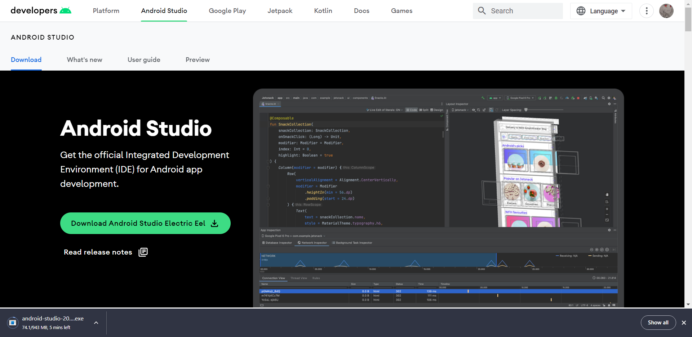

**Step 02:** So, let's launch Android Studio.exe. Make sure before launch Android Studio, our machine/laptop should have required Java JDK installed. After installing JDK, launch Android Studio.exe. file. And choose components and click next as shown below:

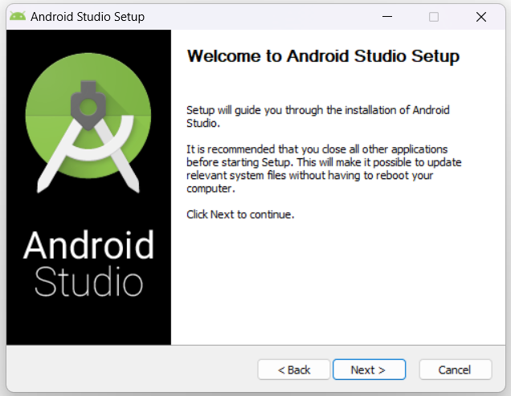 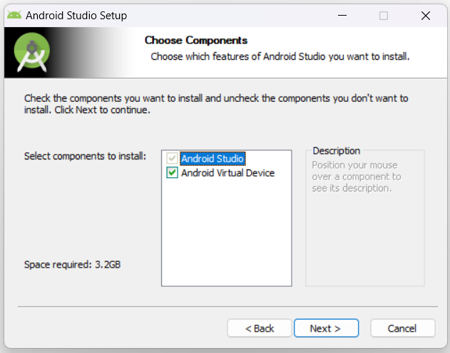

**Step 03:** Here select configuration settings and start menu folder and click Install to install android studio:

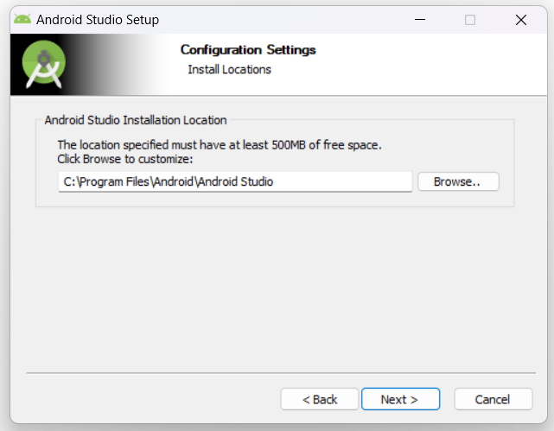 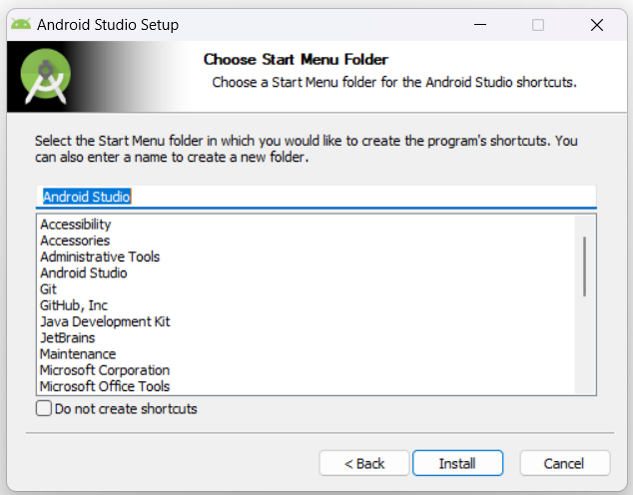

**Step 04:** After clicking install, it will start installing android studio as shown below:

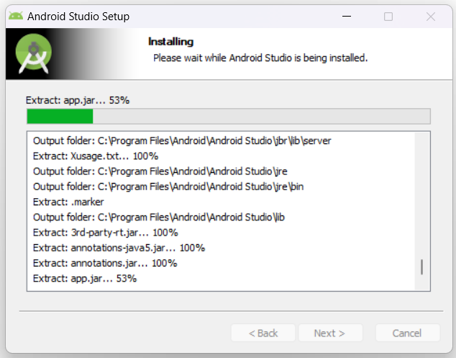 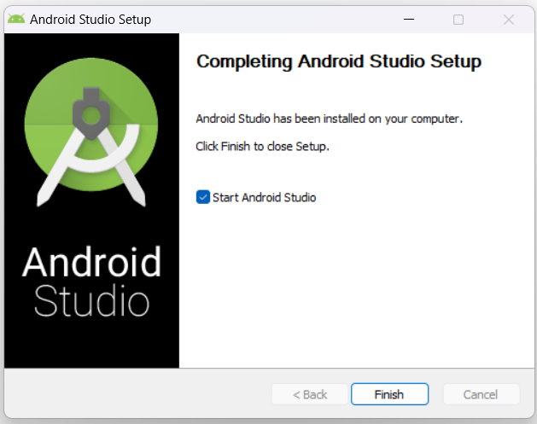

**Step 05:** Now, start Android Studio app and start new project and select activity as “Empty Activity” as shown below and enter activity details such as activity name, package name, save location, language as Java, minimum SDK and then select Finish:

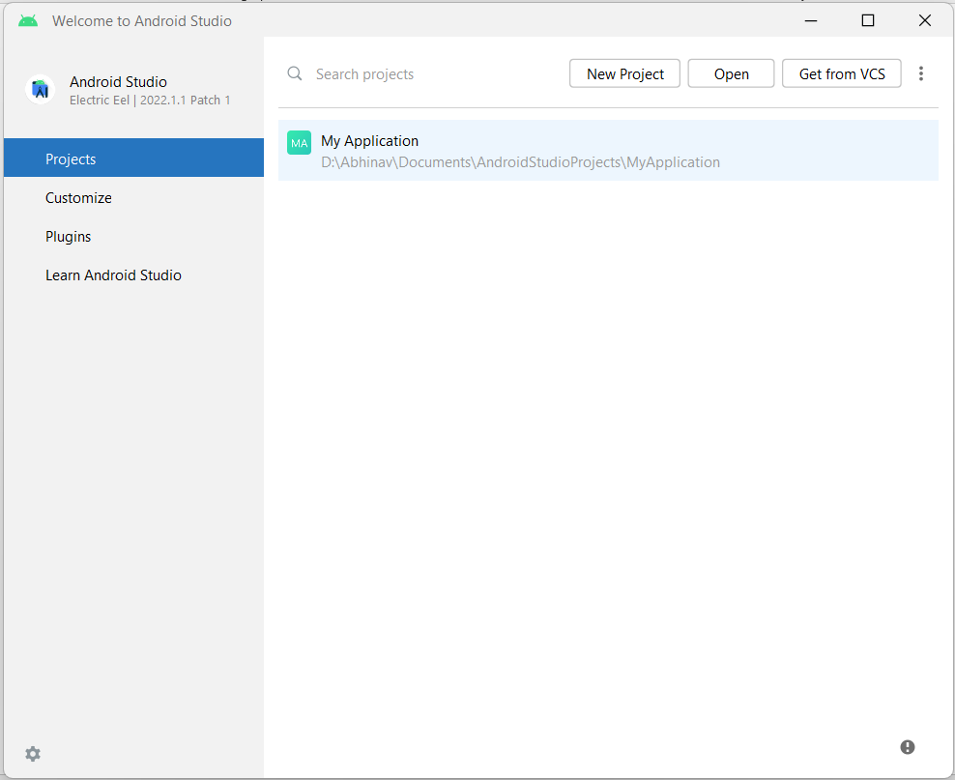 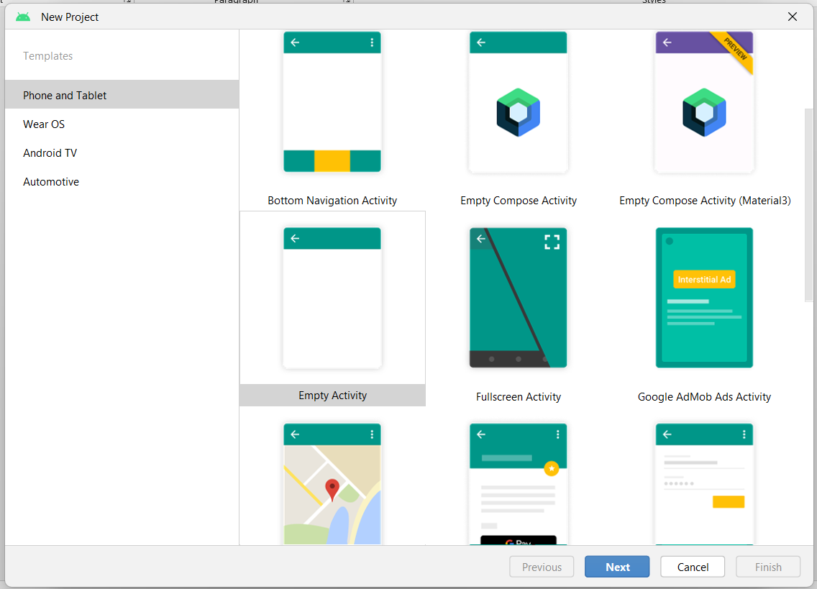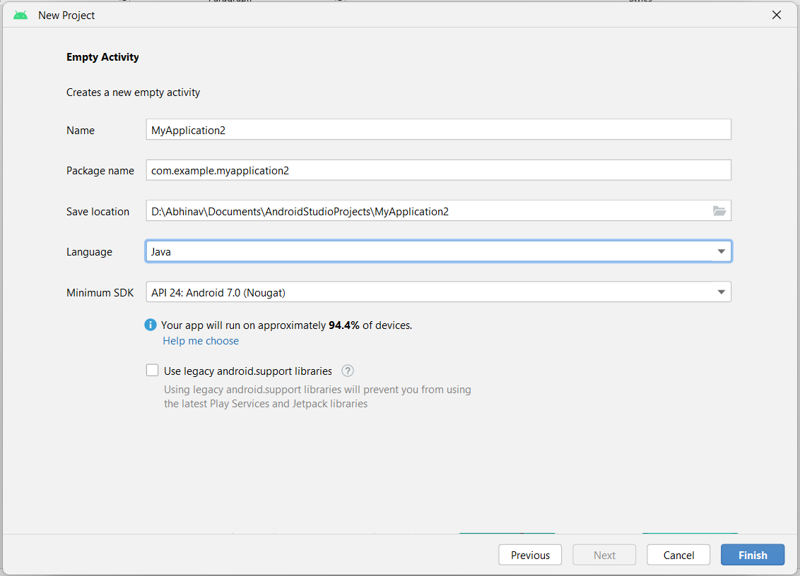

**Step 06:** Now, it will install SDK platform and create new project as shown below:

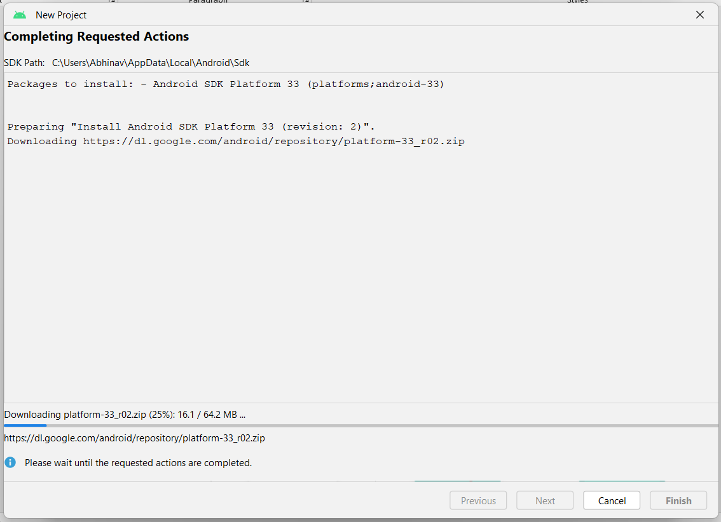

**Step 07:** New window will open with MyActivity.java file, our new project is started as shown below:

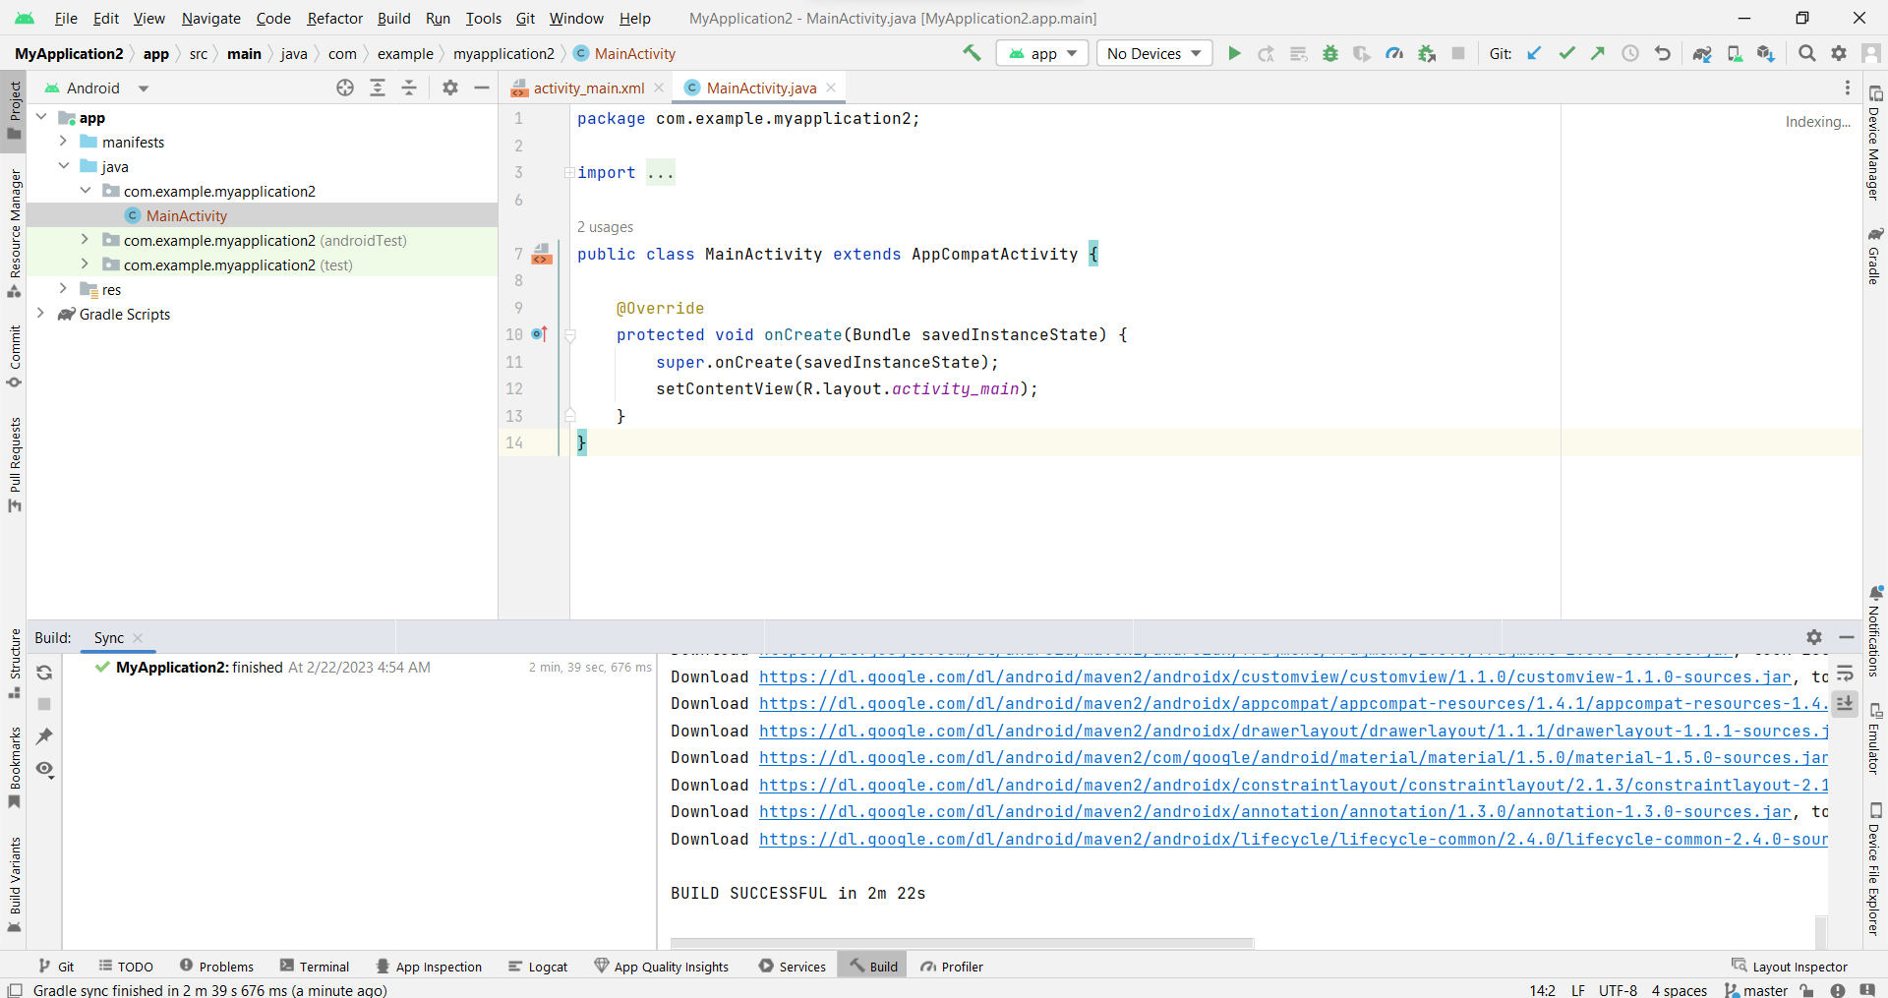

**Step 08:** Now, we will create virtual device where we can run our application click on device manager -> create virtual device -> select category (as Phone) and hardware (Pixel 2) as shown below:

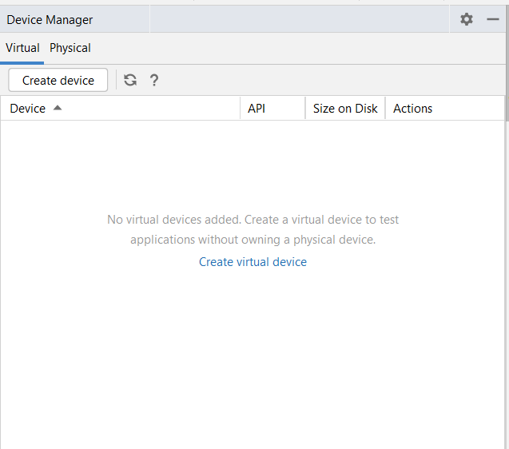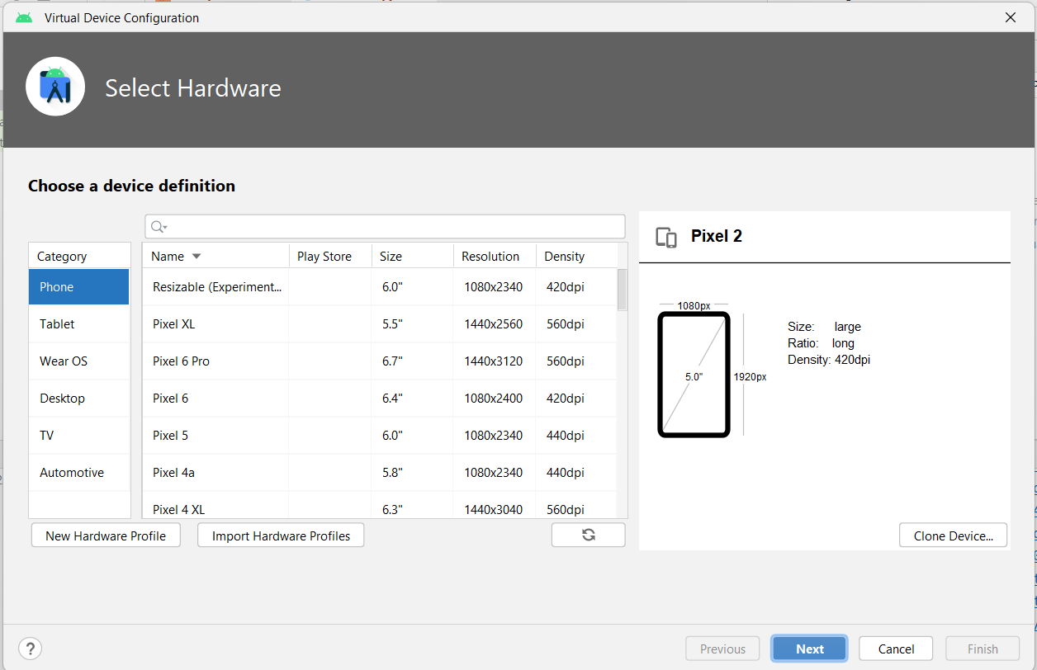

**Step 09:** Now, select OS version (R, android version 11) and give Android Virtual Device (AVD) name (as Pixel 2 API 30) and your virtual device is ready to run applications as shown below:

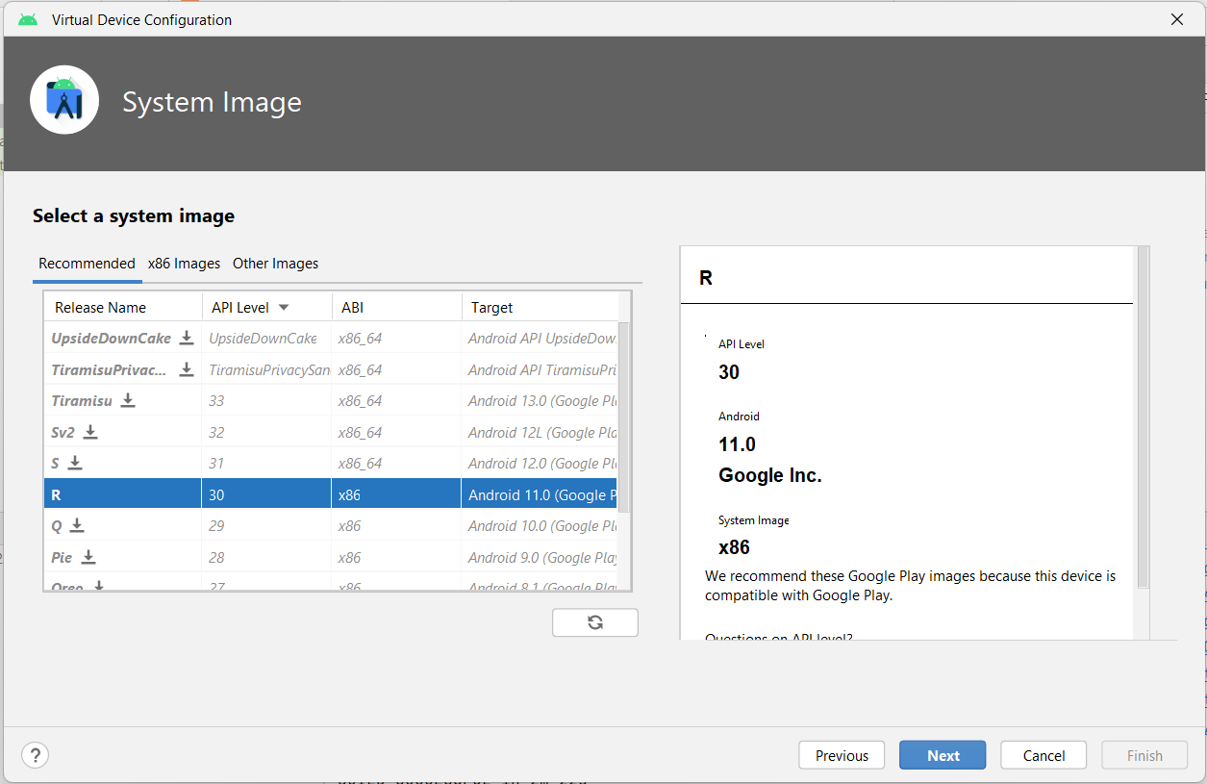

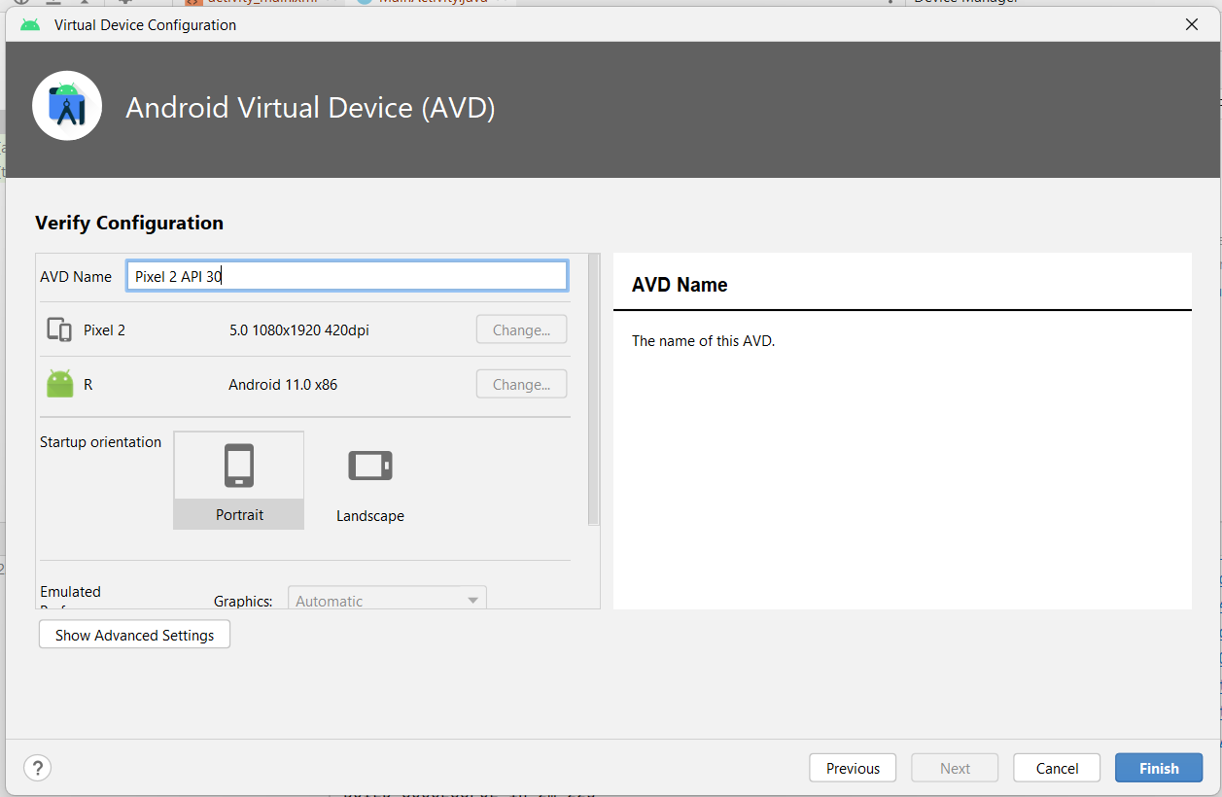

**Step 10:** Now, from Device Manager, select Pixel device as emulator or virtual device to run our application as shown below:

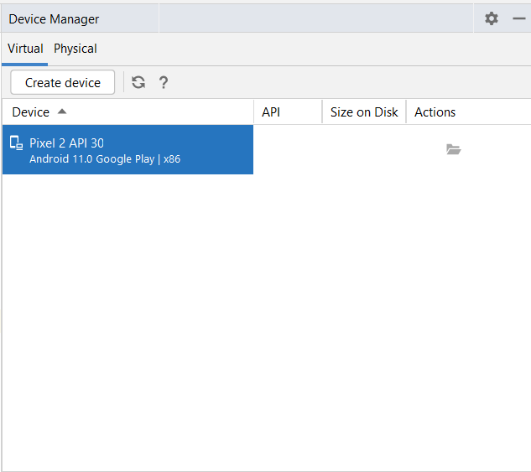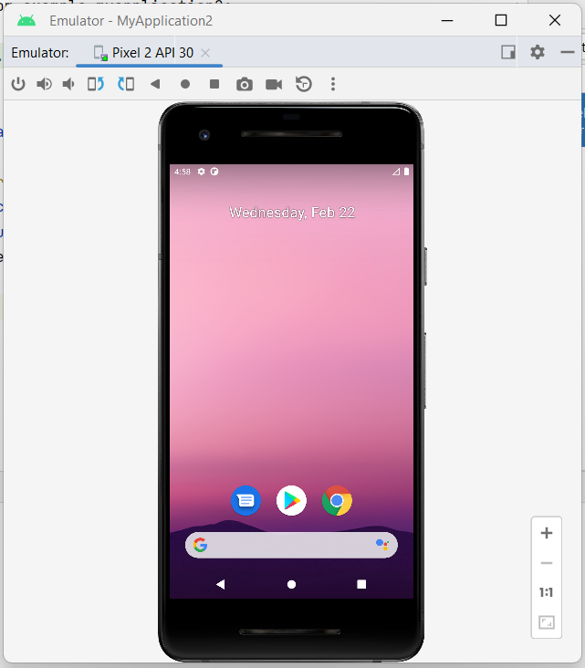

Now, our Android Studio installation and configuration is complete and we can start our android project.